**RBG- CODE DATE Run Book**

|  |  |
| --- | --- |
| Created By: | Arunagiri |
| Created On: | July 12th 2018 |
| Version: | V0.1 |

**Scheduling**

The RBG- CODE DATE runs on the following schedule (US Central Time):

|  |  |
| --- | --- |
| **START_TIME** | **EXPECTED END_TIME** |
| 2:00 AM | 4:00 AM |

**User Communication**

Doesn’t require any user communication.

**General Information**

Main Policy Name: CodeDate

Main Policy location: RHPOIS06\Cognos\RBG\CodeDate

SSIS Batch 1: C:\SSIS\EDW\CUSTOMER_PRODUCT_AUDIT_MASTER.bat

Batch file runs in server RHPBIETL3.

Logs:

**ISSUE#1 No failure emails but the job has not completed on time**

1. Check the Opalis policy to see if the job is running and what is running.
2. If the policy is running, then check what object is running by looking at the ‘Log’ tab and see if any object is taking longer than usual and troubleshoot the delay (blocking, data volume, SQL slowness, check logs…). Some times Opalis policy will get hang then restart the policy by sending email to $Opalis with subject line:

birestart- CodeDateETL

1. If the policy is not running, then look at issue#2 on how to troubleshoot

**ISSUE#2 RBG- CODE DATE** **failed due to below issue**

If RBG- CODE DATE  job got failed at IORDER_RBG_CODE_DATE_R package due to Cannot open the data file

**Error Message: Cannot open the datafile "****\\springfield\apps\Cognos\ETL\Data Sources\RBG\iOrder\CodeDateExport.txt****".**

Manually check the source file location

**\\springfield\apps\Cognos\ETL\Data Sources\RBG\iOrder\CodeDateExport.txt**

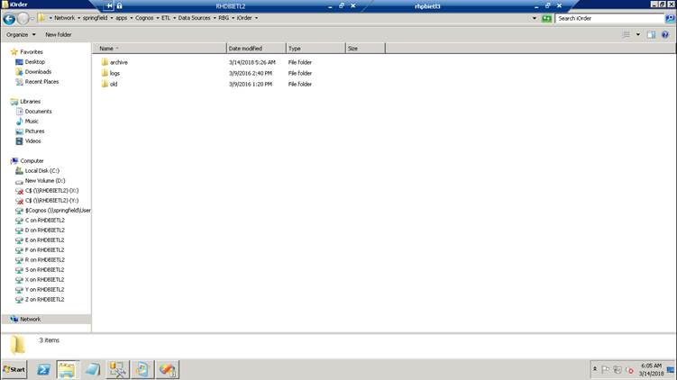

**Step1 :** If no file found then there is a java object that generates the file, run the below java cmd manually via command line by RDP into the PRG1 server in the mentioned working folder .

**Command** : java -jar CodeDateGetter.jar PROD

**Working folder**: C:\Program Files\Java\Java ETL\prod\

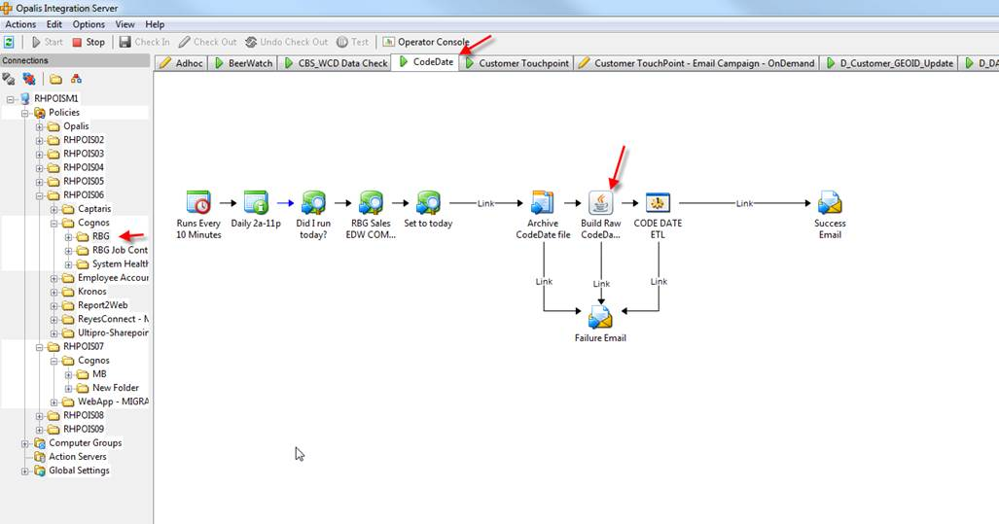

**Step2:** Once file is generated in the source file location then run the below .bat file on ETL3 server.

C:\SSIS\EDW\CUSTOMER_PRODUCT_AUDIT_MASTER.bat